**Database Schema**

**Relational Tables**

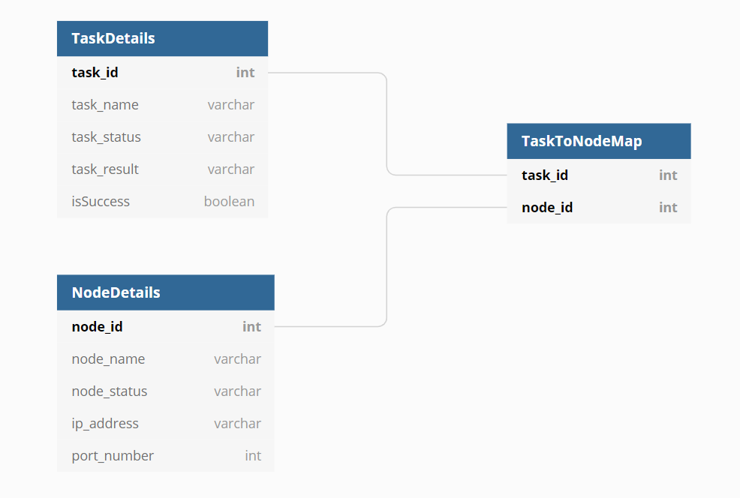

**Task Details**

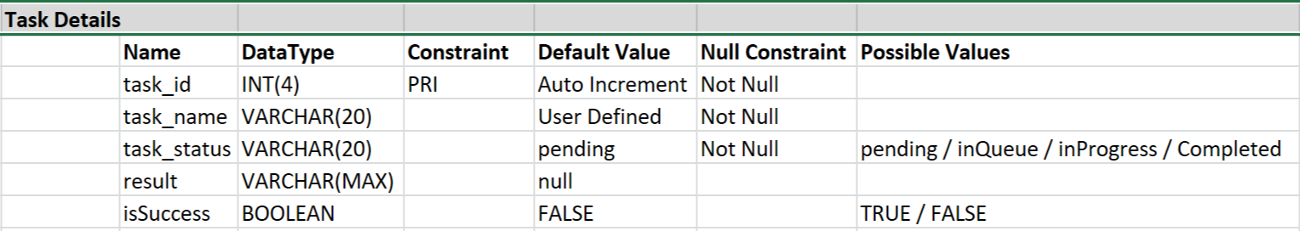

**Node Details**

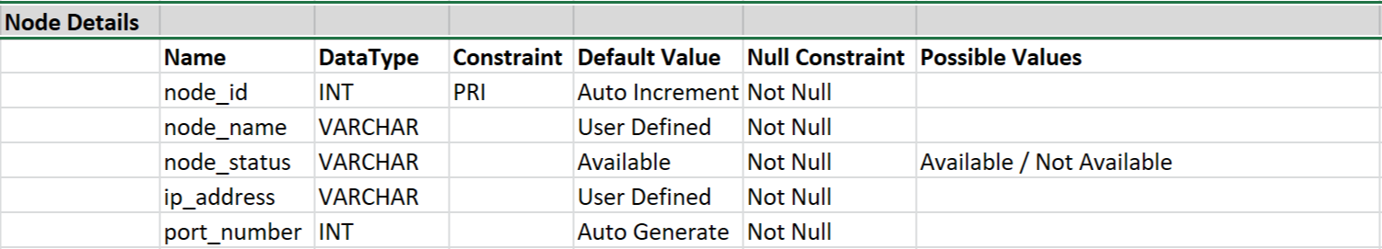

**Task to Node Mapping**

